Nervous system – crash course video worksheets Name __________________________________

- What are the three main processes in the nervous system?

______________________→______________________→______________________

- Complete the following:
S_____________

P_____________

M_____________
Division (A_________)
S_____________
Division (E________)
C_____________
Nervous System (CNS)
A_____________
Nervous system (I______________)
S_____________
Nervous system (V_____________)
P_____________
Nervous System (PNS)

- The main cells are called _____________. The other cells like ‘glue’ are ________________
- Label the following diagram:

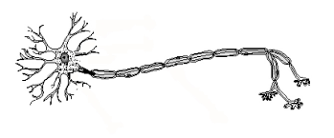

- Dendrites are like the L_______________
- The axon is like the T_______________
- Axons transmit impulses ________________________ the cell body
- Complete the following table with dot points and diagrams
Sensory neurons | Motor neurons | Relay neurons (a.k.a interneuron or association neuron)

- *think* - when he described automatically kicking your leg out, what is this an example of?

R_________________ A__________

Nervous system part 3 - synapse
- The synapse is the ____________________________________ between two neurons (But it doesn’t touch!)
- The signal is transformed from e________________ (action potential) to c______________ (neurotransmitters)
- Electrical synapses are ________________ than chemical signals but _____________ to control
*note – electrical synapses are not common in an adult except in the heart*
- Chemical synapses use _______________________ that _________________ across the gap (a.k.a synaptic cleft)
- P__________________ _____________→ P________________ t_______________→ n_____________________ released → goes across s___________________ c__________________ → accepted by d____________________ of p____________________ n___________________
- Neurotransmitters are stored in v__________________________ in the presynaptic neuron. When they are released they diffuse across the synaptic cleft and bind to the r____________________ on the dendrite of the postsynaptic neuron.
- When a neurotransmitter binds, it can cause the neuron to get _________________ or _________________________

